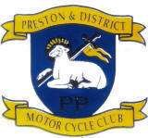

Preston & District Motorcycle Club

MEMBERSHIP FORM

**MEMBERSHIP FORM**

**You can also renew your membership by logging into**

<https://acu.sport80.com/public/wizard/a/1568>

**Or please use this application form**

**APPLICATION FOR MEMBERSHIP YEAR_________**

Name:_____________________________________________________________________________________

DOB ____________________________________ ACU Licence No _______________________________

Address:____________________________________________________________________________________

____________________________________________ Postcode: ______________________________________

Telephone No:_________________________________ Email :____________________________________

Membership £15.00

Please complete this application for membership and return to :-

Email membership.pdmcc@gmail.com

And do a Bank Transfers to HSBC:- Preston & District Motorcycle Club Account Number 01466119 Sort Code 40 37 25 Ref your Name / Membership .